**Technical Design**



**Date:** 29-09-2014  
**Place:** Breda  
**Version:** 1.0  
**Names:** Kevin Ly, Pieter Hoek and Marco Havermans  
**School:** Radius College  
**Class:** APO2A/B  
**Projectgroup:** 6

Table of Contents

1. Tasks 3

1.1 Tasks: 3

2. Modeldictionary 4

2.1 Modeldictionary Tabel 4

3. Classdiagram 5

4. Datadictionary 6

4.1 Tbl_Customers 6

4.2 Tbl_Projects 7

4.3 Tbl_Users 7

4.4 Tbl_Invoices 8

4.5 Tbl_Appointments 8

5. Sequencediagrams 9

6. Versions 10

# 1. Tasks

# 1.1 Tasks:

**- Create a database** - Create tables (Marco Havermans)  
 - Create fields (Marco Havermans)  
 - Create primary and reference keys (Marco Havermans, Kevin Ly)  
 - Linking tables (Marco Havermans, Kevin Ly)  
 ***Check the database*** - Check tables (group)  
 - Check fields (group) (group)  
 - Check primary and reference keys (group)  
 - Check links between tables (group)

**- Create an application**  
 - Create a design of the prototypes (Pieter Hoek, Kevin Ly)  
 *- Program codes*  
 *- Create classes (group)  
 - Program with code (group)  
 - Build the solution and include database (group)*  
 ***Check the application*** - Check the classes of the application (group)  
 - Check the program code (group)  
 - Check the working solution with database (group)

**- Create a acceptation test** - Create the acceptation test (Pieter Hoek)  
 - Let external people test (Pieter Hoek)  
 **Update the application with the acceptation test** - Optimize the application (group)  
 - Test the application so the application fully works (group)

# 2. Modeldictionary

# 2.1 Modeldictionary Tabel

|  |  |
| --- | --- |
| Klasse | Omschrijving |
| Klanten | Een of meerdere personen die betalen voor de diensten die het bedrijf levert. Klanten is verantwoordelijk voor het bijhouden van basisgegevens van een klant. |
| Appointments | Een of meerdere afspraken met een klant. Appointments is verantwoordelijk voor het bijhouden van de afspraken met klanten. |
| Projects | Een of meerdere projecten van een klant. Projects is verantwoordelijk voor het bijhouden van de projecten van klanten. |
| Invoices | Een of meerdere facturen van een klant. Invoices is verantwoordelijk voor het bijhouden van de facturen van klanten. |
| Users | Een of meerdere gebruikers van de applicatie. Users is verantwoordelijk voor het toevoegen en verwijderen van gebruikers. |

# 3. Classdiagram

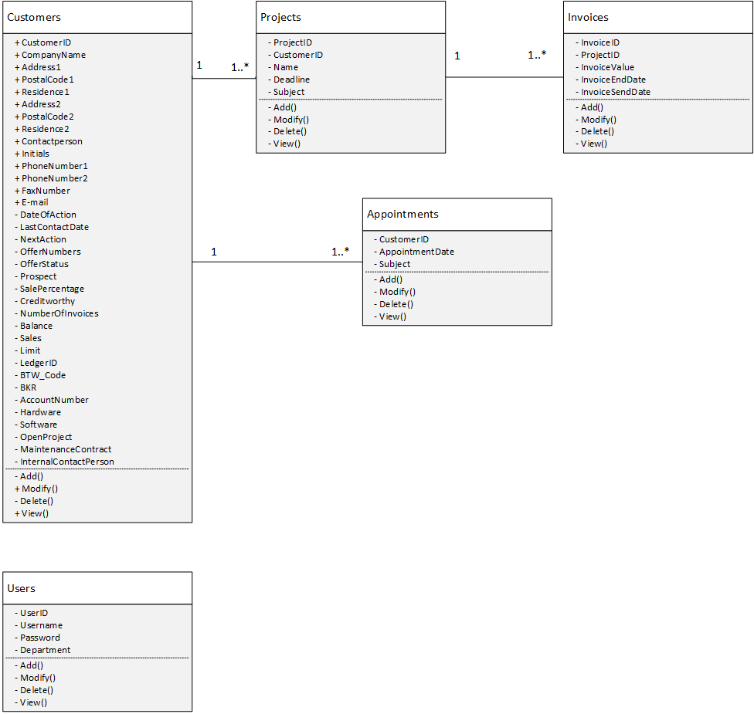

# 4. Datadictionary

## 4.1 Tbl_Customers

|  |  |  |  |  |
| --- | --- | --- | --- | --- |
| Data (gegeven) | Type(type) | Range of values (waardenbereik) | Required (verplicht) | Description(beschrijving) |
| CUSTOMER_ID | Int | 0 .. 2147483647 | Yes | Identify the customer |
| COMPANYNAME | Varchar | Aaaaaaaaa..Zzzzzzzzz(30) | Yes | Name of the company |
| ADDRESS1 | Varchar | Aaaa..Zzzz_ 0..9999 | Yes | Address1 of the customer |
| POSTALCODE1 | Varchar | 1000..9999_AA..ZZ | Yes | Postcalcode1 of the customer |
| RESIDENCE1 | Varchar | Aaaaaaaaa..Zzzzzzzzz (30) | Yes | Residence1 of the customer |
| ADDRESS2 | Varchar | Aaaa..Zzzz_ 0..9999 | No | Address2 of the customer |
| POSTALCODE2 | Varchar | 1000..9999_AA..ZZ | No | Postcalcode2 of the customer |
| RESIDENCE2 | Varchar | Aaaaaaaaa..Zzzzzzzzz (30) | No | Residence2of the customer |
| CONTACTPERSON | Varchar | Aaaaaaaaa..Zzzzzzzzz (30) | Yes | Contactperson of the customer |
| INITIALS | Varchar | AAA...ZZZ(10) | Yes | Initials of the customer |
| PHONE_NR1 | Int | (0100..9999)0000000..9999999 | Yes | Phonenumber1 of the customer |
| PHONE_NR2 | Int | (0100..9999)0000000..9999999 | No | Phonenumber2 of the customer |
| FAXNUMBER | Int | (0100..9999)0000000..9999999 | No | Faxnumber of the customer |
| EMAIL | Varchar | Aa..Zz ||!@~ || 0-999999 (30) + "@" + Aa..Zz (20) + "." + Aa.Zz (10) | Yes | E-mail address of the customer |
| DATE_OF_ACTION | Date | YYYY-MM-DD | No | The date of action |
| LAST_CONTACT_DATE | Date | YYYY-MM-DD | No | The last known contactdate |
| NEXT_ACTION | Date | YYYY-MM-DD | No | The date of next action |
| OFFER_NUMBERS | Int | 0..2147483647 | No | The numbers of offers |
| OFFER_STAT | Bool | Yes/No | No | Is the offer paid? |
| PROSPECT | Bool | Yes/No | Yes | Is the customer prospect? |
| SALE_PERC | Decimal | 0,00..100,00 | No | The percent of Sales |
| CRED_WORTH | Bool | Yes/No | Yes | Customer can pay? |
| NR_OF_INVOICES | Int | 0..2147483647 | Yes | The number of invoices |
| BALANCE | Int | 0..2147483647 | Yes | The balance of paid and not-paid invoices |
| LIMIT | Int | 0..2147483647 | Yes | The border of maximum balance |
| LEDGER_ID | Int | 0..2147483647 | Yes | A internal number of finance department |
| BTW_CODE | Decimal | 0,00..100,00 | No | The percentage of the BTW |
| BKR | Bool | Yes/No | Yes | Is customer BKR checked? |
| ACC_ID | Int | 0..2147483647 | Yes | The account number of the customer |
| HARDWARE | Varchar | Aaaaaaaaa..Zzzzzzzzz (30) | No | The hardware items of the customer |
| SOFTWARE | Varchar | Aaaaaaaaa..Zzzzzzzzz (30) | No | The software items of the customer |
| OPEN_PROJ | Varchar | Aaaaaaaaa..Zzzzzzzzz (30) | No | Current project state |
| MAINT_CONTR | Bool | Yes/No | Yes | Customer have maintenance contract? |
| INT_CONTACT | Varchar | Aaaaaaaaa..Zzzzzzzzz (30) | No | The internal contact person |

## 4.2 Tbl_Projects

|  |  |  |  |  |
| --- | --- | --- | --- | --- |
| Data (gegeven) | Type(type) | Range of values (waardenbereik) | Required (verplicht) | Description(beschrijving) |
| CUSTOMER_ID | Int | 0..2147483647 | Yes | Identify the customer |
| PROJECT_ID | Int | 0..2147483647 | Yes | Identify the project |
| NAME | Varchar | Aaaaaaaaa..Zzzzzzzzz (30) | Yes | The name of the project |
| DEADLINE | Date | YYYY-MM-DD | Yes | The deadline of the current project |
| SUBJECT | Varchar | Aaaaaaaaa..Zzzzzzzzz (30) | Yes | The subject of the current project |

## 4.3 Tbl_Users

|  |  |  |  |  |
| --- | --- | --- | --- | --- |
| Data (gegeven) | Type(type) | Range of values (waardenbereik) | Required (verplicht) | Description(beschrijving) |
| USER_ID | Int | 0..2147483647 | Yes | Identify the user |
| USER_NAME | Varchar | Aaaaaaaaa..Zzzzzzzzz (30) | Yes | The name of the user |
| PASSWORD | Varchar | Aa..Zz & 0-9(30) & (!@# ~ ) | Yes | The password of the user in ********** |
| DEPARTMENT | Varchar | Aaaaaaaaa..Zzzzzzzzz (30) | Yes | The name of the department |

## 4.4 Tbl_Invoices

|  |  |  |  |  |
| --- | --- | --- | --- | --- |
| Data (gegeven) | Type(type) | Range of values (waardenbereik) | Required (verplicht) | Description(beschrijving) |
| INVOICE_ID | Int | 0..2147483647 | Yes | Identify the invoice |
| PROJECT_ID | Int | 0..2147483647 | Yes | Identify the project |
| INVOICE_VALUE | Money | 0,00 - 99999999,99 | Yes | The amount of invoice that must be paid |
| INVOICE_END_DATE | Date | YYYY-MM-DD | Yes | The last date of invoice |
| INVOICE_SEND | Date | YYYY-MM-DD | Yes | The date of invoice that is sent |

## 4.5 Tbl_Appointments

|  |  |  |  |  |
| --- | --- | --- | --- | --- |
| Data (gegeven) | Type(type) | Range of values (waardenbereik) | Required (verplicht) | Description(beschrijving) |
| CUSTOMER_ID | Int | 0..2147483647 | Yes | Identify of the customer |
| APPOIN_DATE | Date | YYYY-MM-DD | Yes | The date of appointment |
| SUBJECT | Varchar | Aaaaaaaaa..Zzzzzzzzz (30) | Yes | The subject of the appointment |

# 5. Sequencediagrams

## 5.1 Add Customer

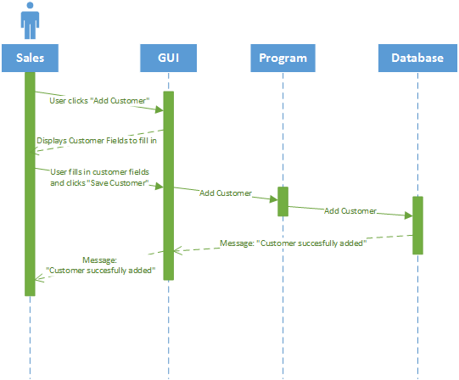

## 5.2 Modify Customer

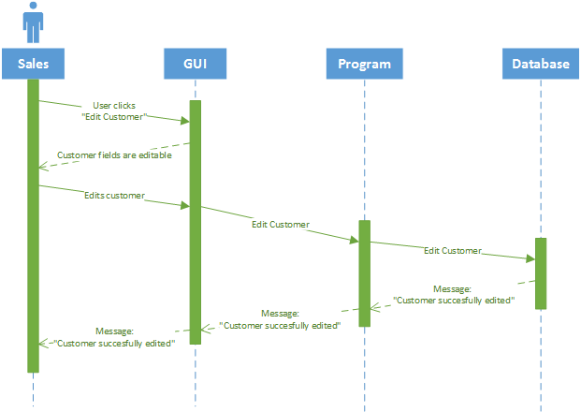

## 5.3 Archive Customer

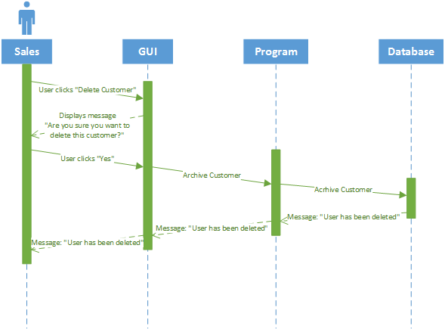

## 5.4 View Customer

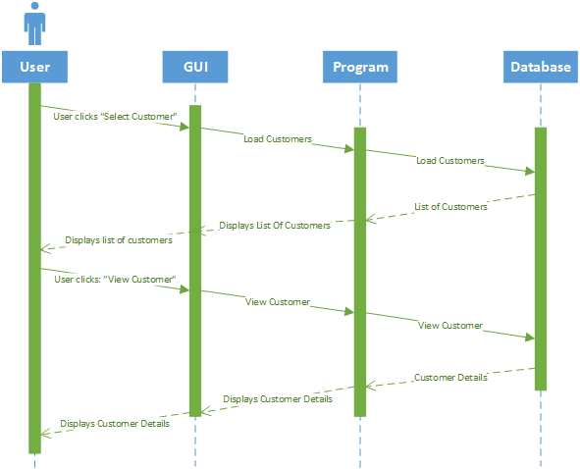

## 5.5 Add Invoice

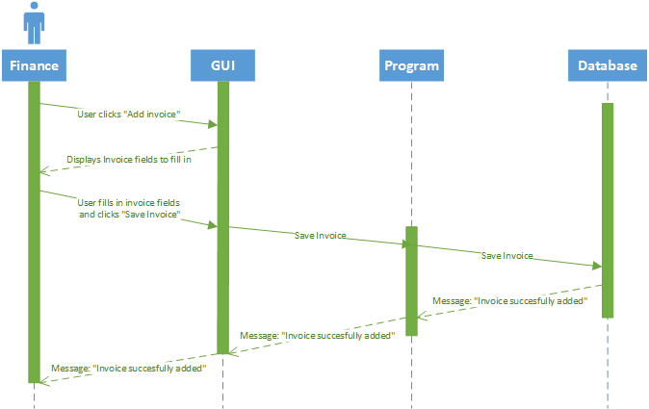

## 5.6 Modify Invoice

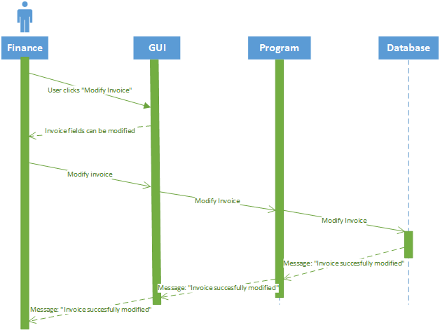

## 5.7 Archive Invoice

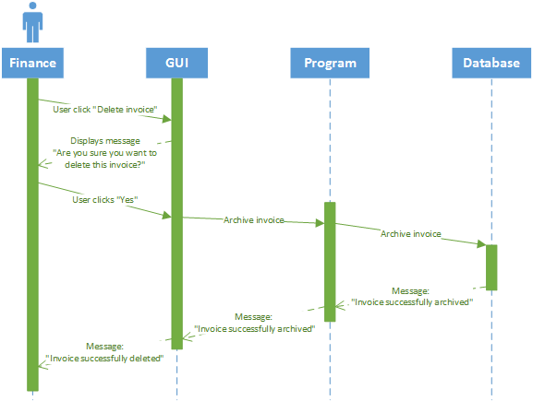

## 5.8 View Invoice

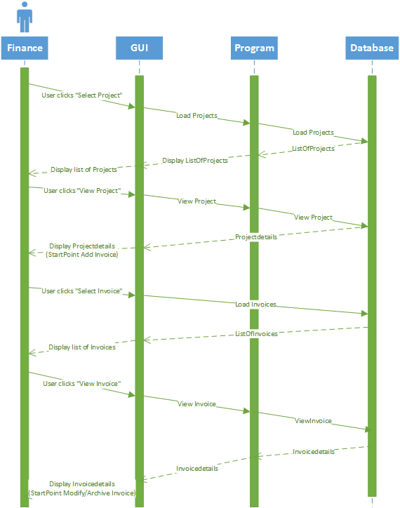

# 6. Versions

|  |  |  |  |
| --- | --- | --- | --- |
| **Version** | **Name** | **Date** | **Description** |
| 0.1 | Kevin Ly, Pieter Hoek and Marco Havermans | 29-09-2014 | * Aanmaken document. * Create modeldictionary, classdiagram, datadictionary and sequencediagrams. * Document include content. |
| 1.0 | Pieter Hoek and Marco Havermans | 29-09-2014 | * Document voorzien van inhoudsopgave. * Document gereed gemaakt. |
| 1.1 | Marco Havermans | 2-10-2014 | * Sequencediagrams en classdiagram toegevoegd |